**Jinal Bangur Hw Assignment 05 Static Code Analysis**

**GitHub URL**: <https://github.com/jinalbangur16/567-B> (On which the test was applied Triangle.py and TestTriangle.py

**Name of code analysis tool used: *Pylama***

**Before Code Analysis:**

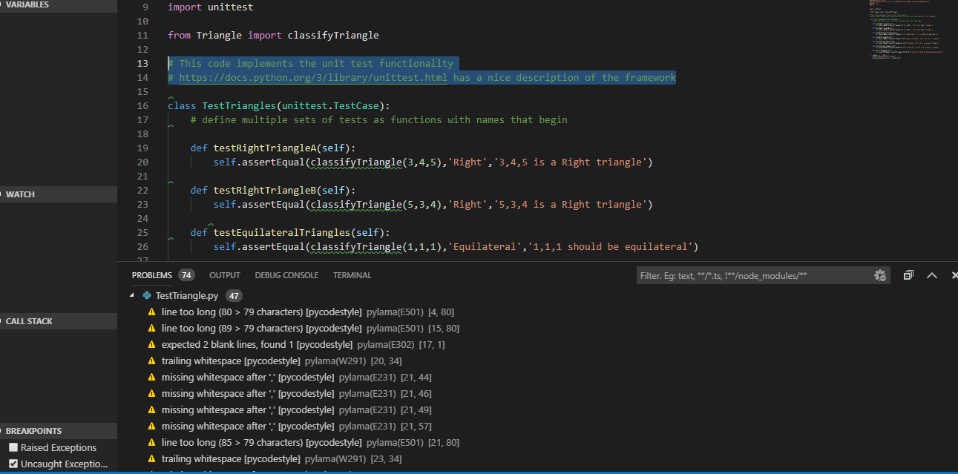

**After Code Analysis:**

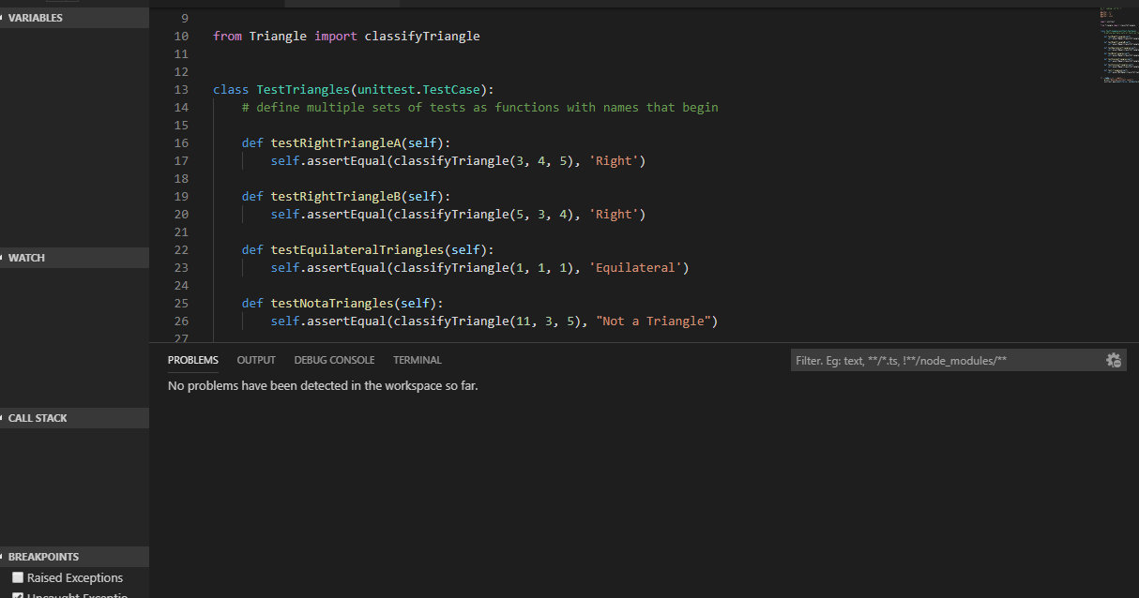

**Name of code coverage tool used: *Markis.code-coverage***

**Before Code Coverage:**

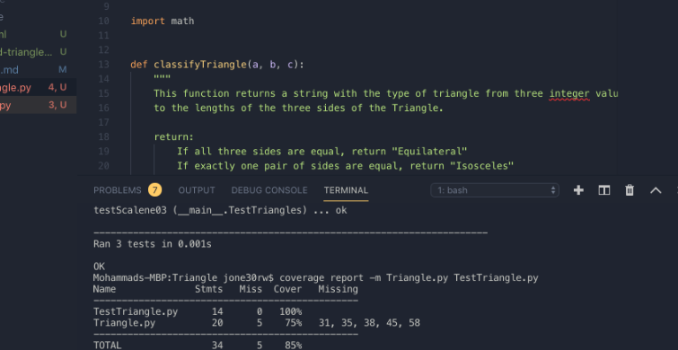

**After Code Coverage:**

